**Electronidex – Market Basket Analysis**

**OBJECTIVE**

Our main objective in this analysis is evaluating data available from Electronidex to find combinations of products that frequently co-occur in transactions. In addition, we also hope to pinpoint high performing items and discover insight into customer preferences and buying patterns.

**DATA**

The data used for this analysis was provided from Electronidex for one month’s (30 days) worth of client online purchase transactions. The data consists of 9,835 separate transactions of the 125 products sold by Electronidex.

**RESULTS**

***The Quick Take*** *– iMac and HP Laptop are both high performing products in terms of sales and the two items most purchased in conjunction with both each other and a variety of other products.*

*In the graph below, we see the 20 top selling products with iMac well in the lead overall. HP Laptop as well as the CYBERPOWER Gamer Desktop also show respectable sales, followed by more Apple products – Earpods and MacBook Air.*

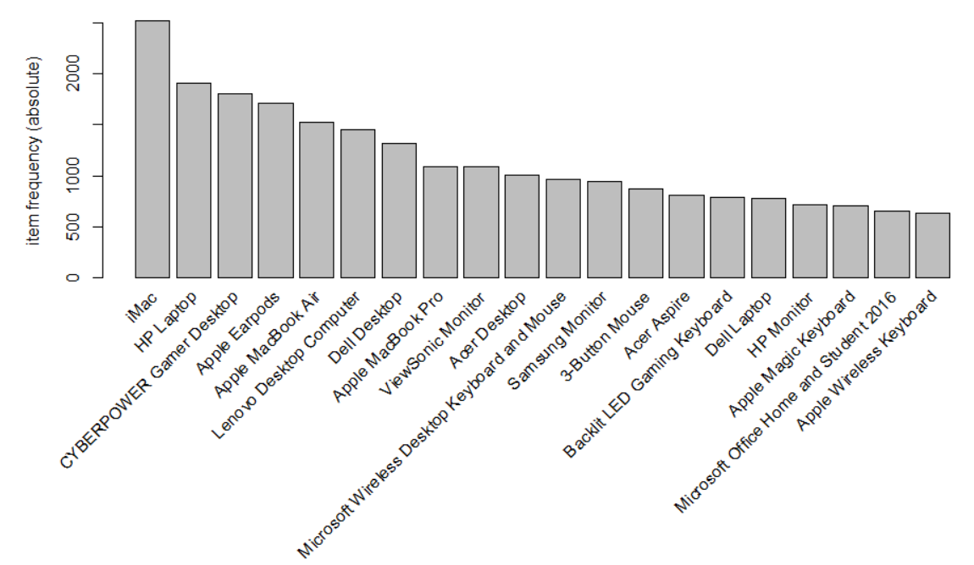

**Results - Best Balance:**

Finding relationships of products purchased together here was a struggle. Our most balanced model was of both fairly low support and confidence set at a support of 0.04 and confidence set at 0.25.

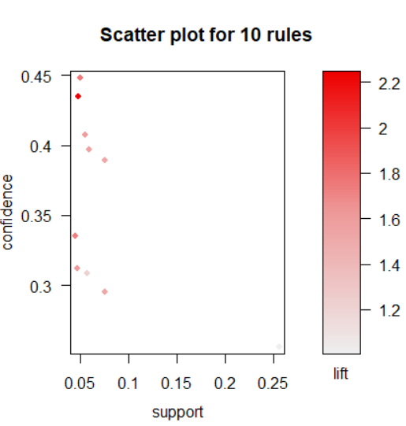

With this support and confidence, we see that iMacs are most often purchased… even solely – 2519 times in fact. The ViewSonic Monitor is often purchased with either the HP Laptop or iMac at 472 times and 486 times respectively. The Dell Desktop was also purchased with either the HP Laptop or iMac at 442 and 537 times respectively. And again the Lenovo Desktop was purchased with either the HP Laptop or iMac 454 and 578 times respectively. The CYBERPOWER Gamer Desktop was purchased with iMac 558 times. Then the two highest seen purchased products – HP Laptop and iMac – were purchased together 743 times.

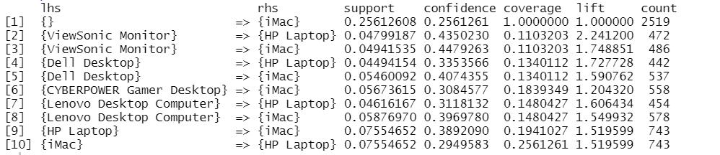

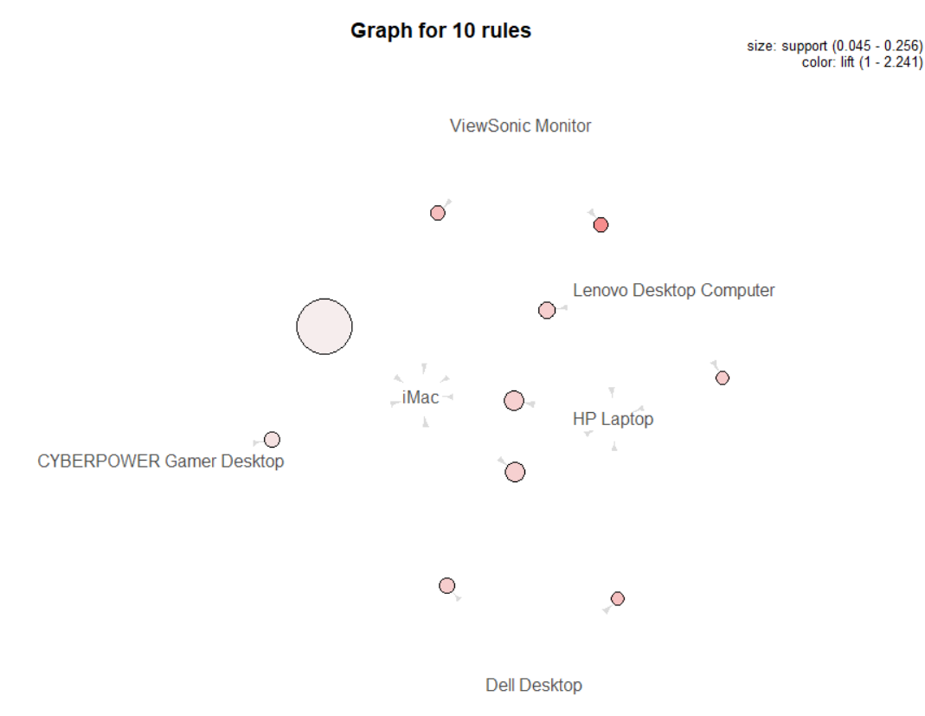

**Results - Highest Support:**

Raising the strength of support for our observations proved an even greater challenge. In attempting to strengthen the support of our observations, we are forced to lower the confidence quiet drastically. And unfortunately, were unable to find many, if any at all, consistent instances of any products purchased together to at a high rate of support regardless of how much we weakened confidence. At best we found instances of single purchases or results that were simply nonsensical. With a support of 0.07 and a confidence of 0.001, the only items purchased together were those we see most often repeat – HP Laptop and iMac again. Unfortunately, given the low confidence required for the rules to generate we cannot award them much in the way of usefulness and certainly cannot claim them to be actionable insights.

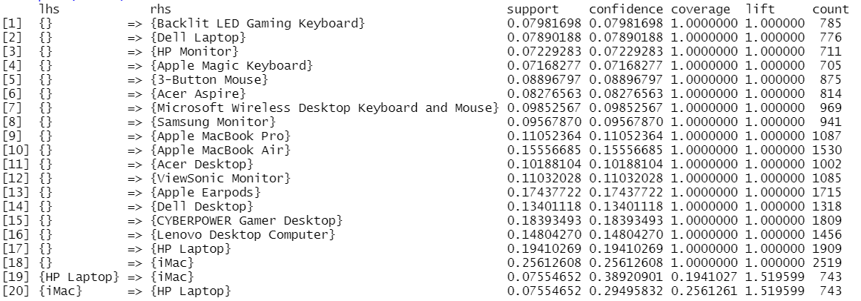

**Results - Highest Confidence:**

Similarly as seen prior, in an attempt to increase our levels of confidence in the observations, we are forced to sacrifice the level of support. When we raise our confidence to 0.9 and lower confidence to 0.003 only one rule is generated. In 37 instances we see that when a Acer Aspire, Dell Desktop, iMac, and ViewSonic Monitor are purchased along with the HP Laptop. Again, given the low support here, we cannot hold this single rule to be a useful or actionable insight.



RECCOMENDATIONS

The greatest takeaway is that iMac’s are king among Electronidex sales. We see iMacs consistently sold at high volume. Of course, it would be beneficial to press Electronidex for more information as to this high sales occurrence. Do they consistently promote and/or run specials on the iMac? But looking only at the numbers and the data provided, it seems Blackwell should as well consider adding iMacs to their available sales products. The very same is to be noted and inquired about the HP Laptop among the Electronidex product lineup as well.

With the limited data available for this analysis, we can neither support nor object to Blackwell’s acquisition of Electronidex. While Electronidex’s transaction numbers appear quite positive for this 30-day period, this limited history leaves us under-informed to provide insight or recommendation of strong conviction